**COMP1003: Maths Worksheet**

For questions 1 to 3 consider the regular expression a(b|c)+d*

1. List the 5 shortest strings of the formal language characterised by the expression.
2. Draw a deterministic finite state automaton that accepts the language generated by the expression.
3. Formulate a grammar that is equivalent to the expression, which means it generates the same strings.
4. Construct a regular expression for international phone numbers.
5. Find a regular expression that is equivalent to this DFA.

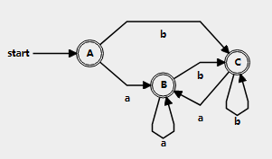

1. Consider the context-free grammar

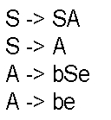

1. Describe informally (in words) the language generated by the grammar.
2. Write down a derivation of the word beebee.
3. For the word beebee draw a syntax tree.
4. Find contect free grammars for the following formal languages

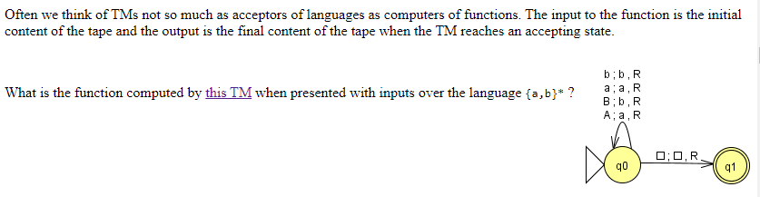

Note: a rule “a; b; X” means: If an a was read, write back a b and do X, where X can be move to the right (R), move to the left (L), or don’t move. The triangle on the left indicates the start state and the little square is the blank tape symbol.